Develop a vb project to search the number using binary search

Form design:

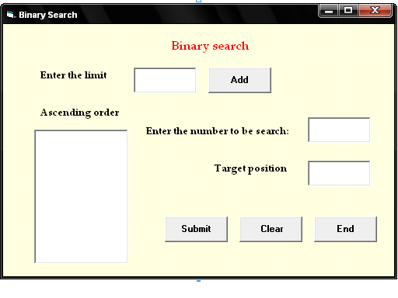

Properties:

Contorls | Name | Caption
Text1 | Text1
Text2 | Text2
Text3 | Text3
List1 | List1
Command1 | Cmdadd | Add
Command2 | Cmdsubmit | Submit
Command3 | Cmdclear | Clear
Command4 | Cmdend | end

6.Binary search
Aim:
To develop a vb project to search the number using binary search

Coding:
Dim a(50) As Integer
Dim i, j, x, n, t, low, upp, middle As Integer

Private Sub Cmdend_Click()
End
End Sub

Private Sub Cmdsubmit_Click()
x = Val(Text3.Text)
low = 0
upp = n
While (low <= upp)
middle = CInt((low + upp) / 2)
If (x > a(middle)) Then
low = middle + 1
ElseIf (x < a(middle)) Then
upp = middle - 1
ElseIf (x = a(middle)) Then
Text2.Text = middle
GoTo out
End If
Wend
If (x <> a(middle)) Then
Text2.Text = "Not found"
End If
out:
End Sub

Private Sub Cmdclear_Click()
Text1.Text = " "
Text2.Text = " "
Text3.Text = " "
List1.Clear
End Sub

Private Sub Cmdadd_Click()
n = Val(Text1.Text)
For i = 1 To n
a(i) = Val(InputBox("Enter the number"))
Next i
For i = 1 To n - 1
For j = i + 1 To n
If a(i) > a(j) Then
t = a(i)
a(i) = a(j)
a(j) = t
End If
Next j
Next i
For i = 1 To n
List1.AddItem (a(i))
Next i
End Sub

Output:

